Working Together to Support Our Communities

Dear Colleague
Welcome to the first of what are planned to be regular newsletters from the Council for colleagues in the voluntary and community sectors working with us in helping Brent respond to the COVID-19 coronavirus pandemic. It is intended to give an overview of what we are doing here as a council to support our communities and of resources and support from other agencies that can be drawn on.
Recent events have proved the value of our new approach to working together, drawing together the strengths, resources and partnerships the council, other agencies and Brent’s incredibly rich voluntary and community sector bring to meeting the needs of our Borough, its people and neighbourhoods. Never has this been more important; never have the potential benefits been so huge. The pandemic raises formidable challenges for us all; these can be met if we make the most of skills, knowledge and commitment across sectors. Not only can we help Brent through these difficult days, but we can help make our Borough an even more supportive, cohesive community. None of us can tackle this crisis alone; together we can demonstrate the value of a cohesive, inclusive borough facing and overcoming common problems together.
The outbreak challenges us all like never before. Here in Brent there is a range of support available to help and this will change and expand as the situation unfolds. This newsletter gives further information about what is available; future editions will tell you about new resources and initiatives. It will also provide a forum for exchanging information about action on the ground. Contact details so you can let us know about things that could appear here are given at the end of the newsletter. We welcome your feedback, so if you have any comments on this newsletter and what it should cover, please let us know!

Shazia Hussain
Assistant Chief Executive, Brent Council

Working Together
The Council has put in place arrangements for working with voluntary/community organisations through the outbreak. This is based around seven thematic groups covering different service delivery areas, each led by someone from a designated lead organisation who will work with others in each sector to help ensure a coordinated approach. These will be supported by the Council through an identified officer lead. These arrangements will be coordinated by CVS Brent. The lead for each theme is the point of contact with the council.
Theme | Lead  Organisation
People with Disabilities and Mental Health | Brent Mencap/Brent Carers Centre  Ann O’Neil/Anne-Marie Morris
Older People | Age UK (HHB)  Julian Lloyd
Young People and Children | Young Brent Foundation  Chris Murray
Homeless People | Crisis  Atara Fridler
Foodbanks | Sufra  Rajesh Makwana
Advice and Information | Citizens Advice Brent  Jacqueline Carr
Cultural and Community Groups | Step Up Hub  Tebussum Rashid

To help ensure a coordinated approach, provide information and let people know what help is available, we are asking organisations and community groups providing services during the Covid-19 outbreak (new or established) to provide us with information about themselves, the services they provide and the communities they support. This is done by completing a simple form that can be found here: Community Group form.
Referral Process
To help those accessing our services and particularly vulnerable residents we have developed an easy to use referral approach that is outlined in the following diagram. We would like to ask all organisations who need to make a referral to use this process.
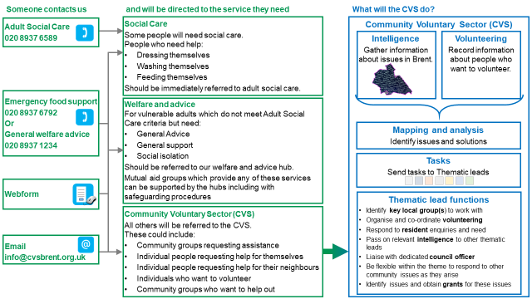

Mutual Aid Groups
Communities and neighbourhoods across Brent have established local groups to provide mutual aid for vulnerable people. Although neither the Council nor the CVS are managing the self-organised groups or what they do, the thematic leads will act as key conduits for sign posting, intelligence gathering and disseminating to support their activities and the needs of local people.
For further support and advice on volunteering, advice and support on the themes then please contact support@cvsbrent.org.uk or 0203 011 1690. The CVS has developed guidance for any self-organised group working with volunteers and this can be found at www.cvsbrent.org.uk. Support and advice on the work of mutual aid groups is also available at: http://covidmutualaid.org//

Please note we are asking any voluntary sector referrals for support or volunteers to be made through the CVS and not the mutual aid groups who are responding to local residents only at this point.

Foodbanks
Brent Council and the Brent Food Aid Network are working together to deliver foodbank services. The process is explained in the diagram below:
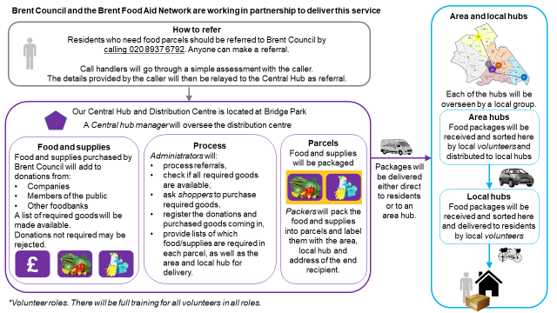

How to Refer:
Residents who need food parcels should be referred to Brent Council by calling 020 8937 6792. Anyone can make a referral. Callers will be taken through a simple assessment; the details provided will be relayed to a Central Hub and Distribution Centre, located at Bridge Park where the foodbank service will be provided.
Anyone wanting to donate to Brent foodbanks should also call 020 8937 6792.

Isolation Support
There are local Brent community groups who can help people needing things like food or medicine to be delivered to them during the current lockdown. For more information call 020 3011 1690.

Volunteering
We are appealing for even more people to step forward to help the borough’s efforts to provide a reinforced safety net for vulnerable residents due to the Covid-19 pandemic.
Eager volunteers have already been recruited through our partners, Community Voluntary Service Brent (CVS), to help deliver food parcels, medicines and other essentials to those who need it most – but now we need more.
Volunteers can sign-up on the Council’s web pages at: https://www.brent.gov.uk/your-community/coronavirus/volunteering/. There, they will find a link to two forms: Volunteering sign up form; and
Community Group form.
Alternatively, call 020 3011 1690.

Brent Community Lottery
Brent Community Lottery is a weekly online lottery established by the Council to support local voluntary groups and good causes in Brent. Tickets are only £1 per week, with 60% cash raised going directly to local good causes and prizes up to £25,000!
Local voluntary groups and good causes have never needed support more and this is an excellent way of generating much needed resources. For more information and to buy a ticket visit - www.brentcommunitylottery.co.uk

Funding opportunities
Council grants and funding
The council offers a range of grants and funding opportunities to voluntary organisations. For more details visit - https://www.brent.gov.uk/your-community/community-and-voluntary-sector-support/community-grants-and-funding/
Brent 4 Community
Brent 4 Community is a community funding support website. Voluntary and community organisations, charities, community groups, social enterprises, and voluntary organisations can search through hundreds of Government, Lottery, charitable trust, and other funds available. Visit
https://www.idoxopen4community.co.uk/brent
London Community Response grant
London Funders is coordinating a £2 million emergency fund provided by the Greater London Authority (GLA) and City Bridge Trust to support community and voluntary organisations facing immediate financial pressures and uncertainty because of COVID-19. Details can be found here.
The first stream of this fund is now opened and is focused on food and essentials – grants of up to £5,000 are available.
Sport England support package
Sport England have announced a support package of up to £195 million to help the community sport/physical activity sector through the outbreak. The package includes:
- a new £20 million Community Emergency Fund, which is open now for local club and community organisations to bid for grants between £300 and £10,000;
- a new £5 million fund for existing Sport England partners facing specific and immediate financial difficulty; and
- £55 million put aside to support the sector during the social distancing restrictions
to fund new and innovative ways to keep people active and, once the outbreak is over, to help organisations get back to business and adjust to a different environment.

Serco Foundation: funding available from the Coronavirus Community Support Fund
Any Serco employee (including those employed by them to provide parking services in Brent) can nominate any voluntary organisation, known to them or their local community, which is providing meaningful and valuable support to others during this worldwide pandemic. For further information and to apply e-mail info@sercofoundation.org The expectation is that grants of £1,000-£5,000 will be given but larger grants will also be considered.

Safeguarding children and vulnerable adults
Everybody has a responsibility to safeguard children and vulnerable adults from harm. When working in the community, you may come across situations that might cause you concern about people you are working with or someone else in the family home. It is vital that you know how to raise concerns about anyone, adult or child. It is essential that if something does not seem right, you raise this as soon as you can – even if you do not have all the information about the situation. There are dedicated Council safeguarding teams for adults and children that will make further enquiries using the information that you are able to provide. See something ….. Say something.
Abuse is any action or inaction by another person – adult or child – that causes harm to a child or vulnerable adult. There are many different types of abuse for example:

- Physical
- Emotional / Controlling behaviour
- Sexual
- Financial
- Domestic Abuse
- Neglect

If you do see something that concerns you, do not try and investigate the matter and do not put yourself at risk. Make a note of the exact location, details of those concerned (if you have them), what you saw and what you heard as soon as you practically can to ensure that you do not forget important information.
Report this information as soon as you are able; details about how to do this are given below. These contacts can also be used if you are concerned about the behaviour of a volunteer working with you, you can also use these contact details. Volunteers expressing concerns about those working with them should be encouraged to bring these to your attention and you can raise them with the Council in the same way.

If you have any concerns that a child or vulnerable adult is being harmed or at risk of harm contact Brent Family Front Door and/or the Safeguarding Adults Team.
Concerned about a child? Contact - Brent Family Front Door
- Telephone: 020 8937 4300
- Online: Brent Council website/safeguarding children

Concerned about a vulnerable adult? Contact – Safeguarding Adults Team
- Telephone: 020 8937 4098
- Email: safeguardingadults@brent.gov.uk
- Online: Brent Council website/adults social care
Domestic Abuse
If you or someone you know is affected by domestic abuse speak to Advance by calling 07398 454898.

For more information on the national guidance to support victims of domestic abuse from the during the Covid-19 pandemic please visit https://www.gov.uk/government/publications/coronavirus-covid-19-and-domestic-abuse/coronavirus-covid-19-support-for-victims-of-domestic-abuse.
If you believe a child/adult is in immediate danger or you have witnessed a crime-taking place you should call the police - call 999.
Emergency support available
Adult Social Care
If you or someone you know needs urgent help washing, feeding or dressing themselves but does not have any friends or family to support them, call 020 8937 6589.

Children at Risk
If you have any concerns about a child being harmed or at risk of harm, call Brent Family Front Door, on 020 8937 4300.

Domestic Abuse
If you or someone you know is affected by domestic abuse, speak to Advance by calling 07398 454898 In an emergency, always call 999.

Emergency Childcare
For emergency childcare (for vulnerable children or children of key workers), call 020 8937 3010.

Housing
If you are homeless, or threatened with homelessness, call 020 8937 2000. If you are a private tenant, and you are being threatened with eviction, call 020 7874 8414.

Person at Risk
If you have any concerns about a person being harmed or at risk of abuse, call the Safeguarding Adults Team on 020 8937 4098.
Contacting the Council

Much of the coverage of the outbreak emphasises using technology to make contact. For people who don’t have internet access, the council is circulating a booklet containing the main council phone numbers to call if people need help. The most important contacts numbers are set out in this newsletter.
Further Information
For more information about the things covered in this Newsletter, visit www.brent.gov.uk/coronavirus.
If you have a question email coronavirus@brent.gov.uk or call 020 8937 1234.

